National University of Computer and Emerging Sciences



**Laboratory Manual**

*for*

*Computer Organization and Assembly Language*

Course Instructors

Lab Instructor(s)

Section

Semester

**Department of Computer Science**

# COAL Lab 7 Manual

|  |
| --- |
| **Objectives:**     * CMP Instruction * JMP and Loop instructions o Unconditional transfer   ▪ JMP instruction  o Conditional transfer  ▪ LOOP instruction   * Nested Loops * User defined input * Problems & Assignments |

## 7.1 CMP instruction

The compare instruction is used to compare two numbers. At most one of these numbers may reside in memory. The compare instruction subtracts its source operand from its destination operand and sets the value of the status flags according to the subtraction result. The result of the subtraction is not stored anywhere. The flags are set as indicated in Table 7.1.

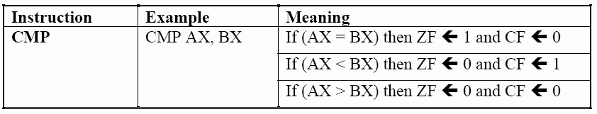

Table 7.1: The Compare Instruction of the 8086 Microprocessor

**Comparisons and Conditions:**

The unsigned comparisons see the numbers as 0 being the smallest and 65535 being the largest with the order that 0 < 1 < 2 … < 65535. The signed comparisons see the number -32768 which has the same memory

|  |  |  |  |  |
| --- | --- | --- | --- | --- |
| **Comparison** | | **Smallest value Largest value** | | |
| **Unsigned**    **Signed** | **DEC HEX** | 0 < 1 < 2 < ……. < | | 128 < ……. < 254 < 255 |
| **DEC**  **HEX** | −128 < −127 < ……. < −1  80h < 81h < ……. < FFh | < 0 < 1 < ……. < 127  < 00h < 01h < ……. < 7Fh | |

Table 7.2: Signed and unsigned number representation using 8 bit

representation as 32768 as the smallest number and 32767 as the largest with the order -32768 < -32767 <

… < -1 < 0 < 1 < 2 < … < 32767. All the negative numbers have the same representation as an unsigned number in the range 32768 … 65535 however the signed interpretation of the signed comparisons makes them be treated as negative numbers smaller than zero. Signed and unsigned number for 8 bit and 16 bit are given below.

|  |  |  |  |  |  |  |  |  |  |
| --- | --- | --- | --- | --- | --- | --- | --- | --- | --- |
| **Comparison** | | **Smallest value Largest value** | | | | | | | |
| **Unsigned**      **Signed** | **DEC** | 0 < 1 < 2 < ……. <  0000h < 0001h < 0002h < ……. < | | 32768 < | ……. | < | 65534 | < | 65535 |
| **HEX** |  | ……. | < | FFFEh | < | FFFFh |
|  | | | | | |
| **DEC** | −32768  ……. < −1 | < 0 < 1 < ……. < 32767  < 0000h < 0001h < ……. < 7FFFh | | | | | | |
| **HEX** | 8000h < 8001h < ……. < FFFFh |

Table 7.3: Signed and unsigned number representation using 16 bit

All meaningful situations both for signed and unsigned numbers than occur after a comparison are detailed in the following table.

|  |  |  |  |
| --- | --- | --- | --- |
| **COMPRAISON** | **FLAGS** | **EXPLAINATION** | **EXAMPLES** |
|  |  | **UNSIGNED COMPARISONS** |  |
| UDEST = USRC OR  SDEST = SSRC | ZF = 1 | When the source is subtracted from the destination and both are equal the result is zero and therefore the zero flag is set. This works for both signed and unsigned numbers. | **EXAMPLE # 1** |
| **MOV** **AX,** **5**  **MOV** **BX,** **5**  **CMP** **AX, BX** ; **ZF = 1** |
| UDEST < USRC | CF = 1 | When an unsigned source is subtracted from an unsigned destination and the destination is smaller, borrow is needed which sets the carry flag. | **EXAMPLE # 2** |
| **MOV** **AX,** **2**  **MOV** **BX,** **5**  **CMP** **AX, BX** ; **CF = 1** |
| UDEST > USRC | ZF = 0  AND  CF = 0 | The unsigned source and destination are not equal if the zero flag is not set and the destination is not smaller since  no borrow was taken. Therefore the destination is greater than the source. | **EXAMPLE # 3** |
| **MOV** **AX,** **5**  **MOV** **BX,** **2**  **CMP** **AX, BX** ; **CF = 0**  ; **ZF = 0** |
|  |  | **SIGNED COMPARISONS** |  |
| SDEST < SSRC | SF OF | When a signed source is subtracted from a signed destination and the answer is negative with no overflow than the destination is smaller than the source. If however there is an overflow meaning that the sign has changed unexpectedly, the meanings are reversed and a positive number signals that the destination is smaller. | **EXAMPLE # 4 (a)** |
| **MOV** **AX,** **2**  **MOV** **BX,** **5**  **CMP** **AX, BX** ; **SF = 1**  ; **OF = 0** |
| **EXAMPLE # 4 (b)** |
| **MOV** **AX,** **8001 H**  **MOV** **BX,** **5**  **CMP** **AX, BX** ; **SF = 0**  ; **OF = 1** |
| SDEST > SSRC | SF = OF | If the zero flag is not set, it means | **EXAMPLE # 5 (a)** |
|  |  | that the signed operands are not equal and if the sign and overflow match in addition to this it means that the destination is greater than the source. | **MOV** **AX,** **5**  **MOV** **BX,** **2**  **CMP** **AX, BX** ; **SF = 0**  ; **OF = 0** |
| **EXAMPLE # 5 (b)** |
| **MOV** **AH,** **64 H**  **MOV** **BH,** **0CE H**  **CMP** **AH, BH** ; **SF = 1**  ; **OF = 1** |

Table 7.4: Situations for Signed and Unsigned comparisons

## 7.2 JMP and LOOP Instruction

By default, the CPU loads and executes programs sequentially. But the current instruction might be conditional, meaning that it transfers control to a new location in the program based on the values of CPU status flags (Zero, Sign, Carry, etc.). Assembly language programs use conditional instructions to implement high-level statements such as IF statements and loops. Each of the conditional statements involves a possible transfer of control (jump) to a different memory address. A transfer of control, or branch, is a way of altering the order in which statements are executed. There are two basic types of transfers:

### 7.2.1 Unconditional Transfer

Control is transferred to a new location in all cases; a new addressis loaded into the instruction pointer, causing execution to continue at the new address. The **JMP** instruction does this.

### JMP Instruction

The JMP instruction causes an unconditional transfer to a destination, identified by a code label that is translated by the assembler into an offset. The syntax is

**JMP** ***destination***

When the CPU executes an unconditional transfer, the offset of *destination* is moved into the instruction pointer, causing execution to continue at the new location.

*Creating a Loop* The JMP instruction provides an easy way to create a loop by jumping to a label at the top of the loop:

**top:**

**.**

**.**

**JMP top ; repeat the endless loop**

JMP is unconditional, so a loop like this will continue endlessly unless another way is found to exit the loop.

### 7.2.2 Conditional Transfer

The program branches if a certain condition is true. A wide variety of conditional transfer instructions can be combined to create conditional logic structures. The CPU interprets true/false conditions based on the contents of the ECX and Flags registers.

### LOOP Instruction

The LOOP instruction, formally known as *Loop According to ECX Counter*, repeats a block of statements a specific number of times. ECX is automatically used as a counter and is decremented each time the loop repeats. Its syntax is

**LOOP *destination***

The loop destination must be within -128 to +127 bytes of the current location counter. The execution of the LOOP instruction involves two steps: First, it subtracts 1 from ECX. Next, it compares ECX to zero. If ECX is not equal to zero, a jump is taken to the label identified by *destination*. Otherwise, if ECX equals zero, no jump takes place, and control passes to the instruction following the loop.

In real-address mode, CX is the default loop counter for the LOOP instruction. On the other hand, the LOOPD instruction uses ECX as the loop counter, and the LOOPW instruction uses CX as the loop counter.

In the following example, we add 1 to AX each time the loop repeats. When the loop ends, AX = 5 and ECX = 0:

**mov ax,0 mov ecx,5 L1: inc ax**

**loop L1**

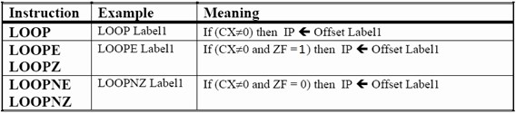

Table 7.5: Summary of the LOOP Instructions.

A common programming error is to inadvertently initialize ECX to zero before beginning a loop. If this happens, the LOOP instruction decrements ECX to FFFFFFFFh, and the loop repeats 4,294,967,296 times! If CX is the loop counter (in real-address mode), it repeats 65,536 times.

Occasionally, you might create a loop that is large enough to exceed the allowed relative jump range of the LOOP instruction. Following is an example of an error message generated by MASM because the target label of a LOOP instruction was too far away:

**error A2075: jump destination too far : by 14 byte(s)**

Rarely should you explicitly modify ECX inside a loop. If you do, the LOOP instruction may not work as expected. In the following example, ECX is incremented within the loop. It never reaches zero, so the loop never stops: **top:**

**. .**

**inc ecx**

**loop top**

If you need to modify ECX inside a loop, you can save it in a variable at the beginning of the loop and restore it just before the LOOP instruction:

**.data count DWORD ? .code**

|  |  |
| --- | --- |
| **mov ecx,100 top:** | **; set loop count** |
| **mov count,ecx .** | **; save the count** |
| **mov ecx,20 .** | **; modify ECX** |
| **mov ecx,count** | **; restore loop count** |

**loop top**

An overview of all the jump instructions is given in Table 7.5.

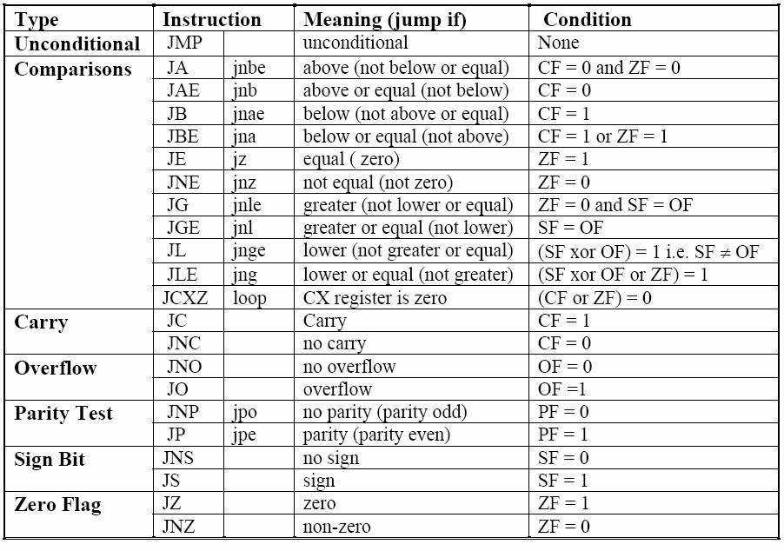

Table 7.6: Jump Instructions of the 8086 Microprocessor

### 7.3 Nested Loops

When creating a loop inside another loop, special consideration must be given to the outer loop counter in ECX. You can save it in a variable:

**.data count DWORD ?**

|  |  |
| --- | --- |
| **.code** |  |
| **mov ecx,100 L1:** | **; set outer loop count** |
| **mov count,ecx** | **; save outer loop count** |
| **mov ecx,20 L2:**  **.**  **.** | **; set inner loop count** |
| **loop L2** | **; repeat the inner loop** |
| **mov ecx,count** | **; restore outer loop count** |
| **loop L1** | **; repeat the outer loop** |

As a general rule, nested loops more than two levels deep are difficult to write. If the algorithm you’re using requires deep loop nesting, move some of the inner loops into subroutines.

### 7.4 User defined inputs

|  |  |
| --- | --- |
| **Command** | **Function** |
| **ReadChar** | Waits for a single character to be typed at the keyboard and returns the character. |
| **ReadDec** | Reads an unsigned 32-bit decimal integer from the keyboard, terminated by the Enter key. |
| **ReadHex** | Reads a 32-bit hexadecimal integer from the keyboard, terminated by the Enter key. |
| **ReadInt** | Reads a 32-bit signed decimal integer from the keyboard, terminated by the Enter key. |
| **ReadString** | Reads a string from the keyboard, terminated by the Enter key. |
| **WaitMsg** | Displays a message and waits for a key to be pressed. |
| **WriteBin** | Writes an unsigned 32-bit integer to the console window in ASCII binary format. |
| **WriteBinB** | Writes a binary integer to the console window in byte, word, or doubleword format. |
| **WriteChar** | Writes a single character to the console window. |
| **WriteDec** | Writes an unsigned 32-bit integer to the console window in decimal format. |
| **WriteHex** | Writes a 32-bit integer to the console window in hexadecimal format. |
| **WriteHexB** | Writes a byte, word, or doubleword integer to the console window in hexadecimal format. |
| **WriteInt** | Writes a signed 32-bit integer to the console window in decimal format. |

# Problem(s) / Assignment(s)

|  |  |
| --- | --- |
| **Discussion & Practice** | **Estimated completion time: 1 hr, 30 mins** |

|  |  |
| --- | --- |
| **Problem 7.1:** *Separating even odd numbers*  Write a program that determines whether an integer is even or odd and display a message of E\O number of times of the input.  **Sample:**  **Enter your value : 3**  **OOO**  **Solution:**  include Irvine32.inc  .data  prompt byte "Enter your value : ", 0  int1 dword ?  prompt2 byte "Number is even ", 0  prompt3 byte "Number is odd ", 0  .code  main proc  mov eax,0  mov ebx,0  mov edx ,offset prompt  Call WriteString  Call ReadDec  mov int1,eax  l1:  add ebx,2  cmp ebx,int1  je Even1  ja odd  jmp l1  Even1:  mov edx ,offset prompt2  Call Writestring  jmp exit1  odd :  mov edx ,offset prompt3  Call Writestring  jmp exit1  exit1 :  exit  main endp  end main | **Estimated completion time:20 mins** |

|  |  |
| --- | --- |
| **Problem 7.2:** *Fibonacci number generation*  Write a program that generate the first six Fibonacci number sequence (1, 1, 2, 3, 5, 8 upto user defined integer). Use an array named Fibonacci of word type. You may initialize the first two places of array with 1’s and next four places with 0. Use the following rule and save results in the same array  The rule to generate sequence is Fn= Fn-1+Fn-2. Call DumpMEM to display Fibonacci sequence.  Solution:  include Irvine32.inc  .data  prompt byte "Enter size for fibonacci : ",0  fibonacci word 2 dup(1),100 dup(0)  var word 100 dup(?)  .code  main proc  mov ebp,4  mov esi,offset fibonacci  mov ebx,offset var  mov eax,[esi]  mov [ebx],eax  mov [ebx+2],eax  mov edx,offset prompt  call writestring  call readDec  mov edx,0  dec eax  mov ecx,eax  L1:  mov eax,[ebx+edx]  inc edx  inc edx  add eax,[ebx+edx]  mov [ebx+ebp],eax  inc ebp  inc ebp  LOOP L1  mov esi,offset var  mov ecx,lengthof var  mov ebx,type var  call dumpmem  exit  main endp  end main | **Estimated completion time:15 mins** |

|  |  |
| --- | --- |
| **Problem 7.3:** *Working with different shapes*  Write a program that takes input from the user and displays the following pattern.  **Sample:**  **Enter your input: 5 Output:**  **\*\*\*\*\***  **\*\*\*\***  **\*\*\***  **\*\***  **\***  Solution:  include Irvine32.inc  .data  msg db "enter a value",0  var dd 1 dup(0)  temp dd 1 dup(0)  var2 dd 0  .code  main proc  mov edx,offset msg  mov ecx,lengthof msg  call writestring  call readdec  mov var,eax  mov var2,1;;;;eax  mov ecx,0  mov ecx,var  l1:  mov temp,ecx  mov ecx,var2  l3:  mov al," "  call writechar  loop l3  mov ecx,var  l2:  mov al,"*"  call writechar  loop l2  dec var  mov ecx,temp  call crlf  inc var2  loop l1  exit  main endp  end main | **Estimated completion time:20 mins** |

**You are done with your exercise(s), make your submission** ☺